TRADEZ
Ana Arellano Beltran
CST-451 Capstone Project Development (Coding Phase)
Grand Canyon University
Instructor: Professor Amr Elchouemi
Revision: 1
Date: 11/23/25

ABSTRACT
Tradez is a community driven mobile and web application designed to simplify and modernize the old practice of bartering. The platform would allow users to facilitate the exchange of goods and services without the need for money, fostering a more sustainable local economy. By integrating geolocation services, Tradez enables the users to connect with other traders nearby in the community, making local bartering more efficient. Additionally, for those users who prefer online interactions or more choices, an online section allows for remote trades, expanding the potential networks.

The main task of the project was to develop a user-friendly marketplace that promotes community without the need for monetary exchange. Some key features that will be included are user profiles, item listings with images, descriptions, category filters, chat functionality, and a rating system to ensure reliability and transparency. The interface will be built with a focus on navigation, modern design, and smooth performance across devices. Backend will be implemented to manage authentication, data storage, and location-based searches efficiently.

Tradez accomplishes the goal of bringing traditional barter systems with modern digital tools. It will empower those in the community to exchange without financial constraints and help others. It will reduce waste through item reuse and encourage community interaction. Tradez represents a meaningful step toward a more circular and connected economy, one where people trade not just goods but trust and mutual benefit.

History and Signoff Sheet
Change Record
Date | Author | Revision Notes
11/23/25 | Ana Arellano Beltran | Initial draft for review/discussion

Overall Instructor Feedback/Comments

Overall Instructor Feedback/Comments
Integrated Instructor Feedback into Project Documentation
☐ Yes ☐ No

Table of Contents
Implementation Plan 5
Mapping of Functional Requirements 5
Source Code Listing 5
Test Plan and Test Cases 13
Application Demonstration 13

Implementation Plan
CST-451 Tradez Sprints.xlsx
For my Tradez application, the implementation plan outlines all the development activities needed to complete the user stories for the project using Agile Scrum approach. I will be using Excel to organize my user stories, development tasks, estimated hours, actual hours, and the percent complete. The plan will break down all the necessary features such as offer requests, messages, trade management, security, product reviews, etc. into smaller manageable tasks. Tracking the progress in Excel will help stay organized. The sprint planning will help the pace of development, provide clear visibility of progress, and ensure continuous integration of features through the project timeline.

Mapping of Functional Requirements
CST-451 Tradez Traceability Matrix .xlsx

Source Code Listing
This section will contain the source code for the Tradez application with a brief description of the class and files. It follows MVC and currently contains the folders controller, data, models, and service. It includes css and the html templates in the resources/static folder.
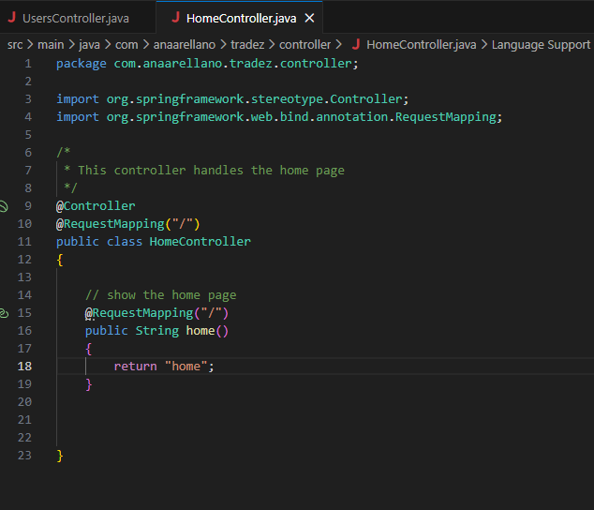
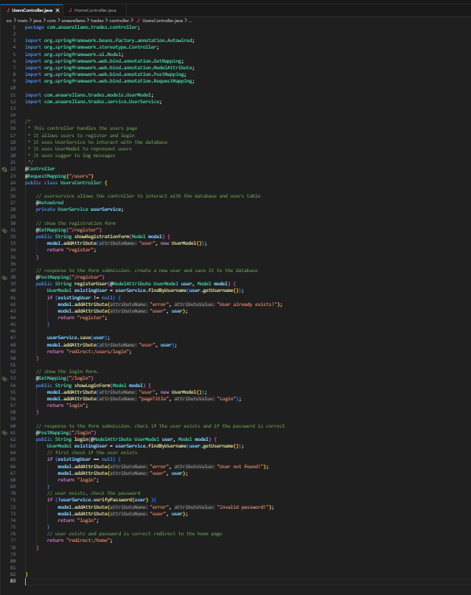
The controllers folders currently contains two classes the UsersController and the HomeController. The HomeController has a basic method that simply displays the home page. The UsersControllers handles the register and login, it will show both and reach into the UserService to create a new user or check if the user exists and if the password is correct.

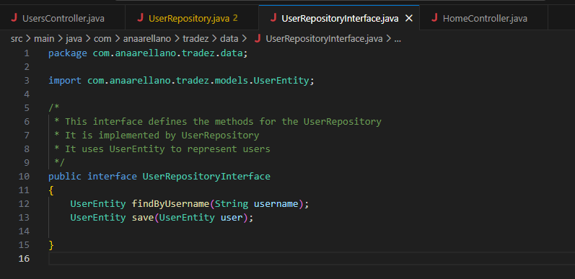
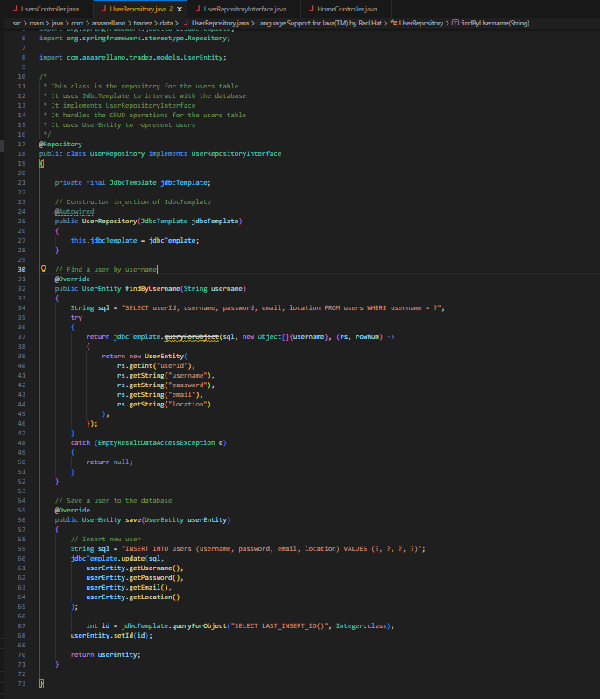

The data folder currently has the UserRepository and the UserRepositoryInterface they each work to create the CRUD methods for users. The UserRepository uses JDBC and sql statements to interact with the database. It currently only contains the findByUsername and save methods. The UserRepositoryInterface will define the methods for the actual repository. It currently only has the findByUsername and save methods.

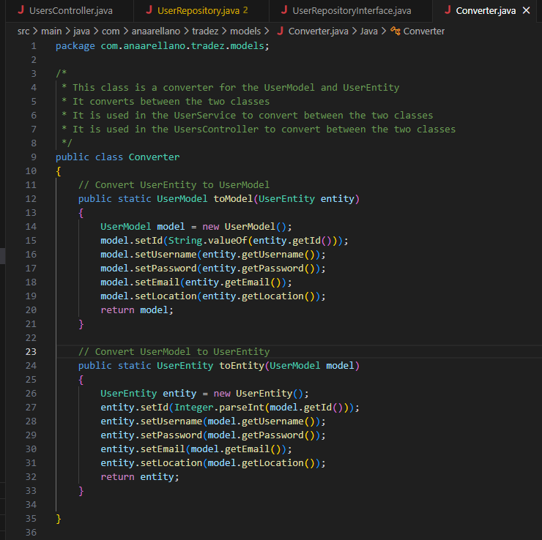
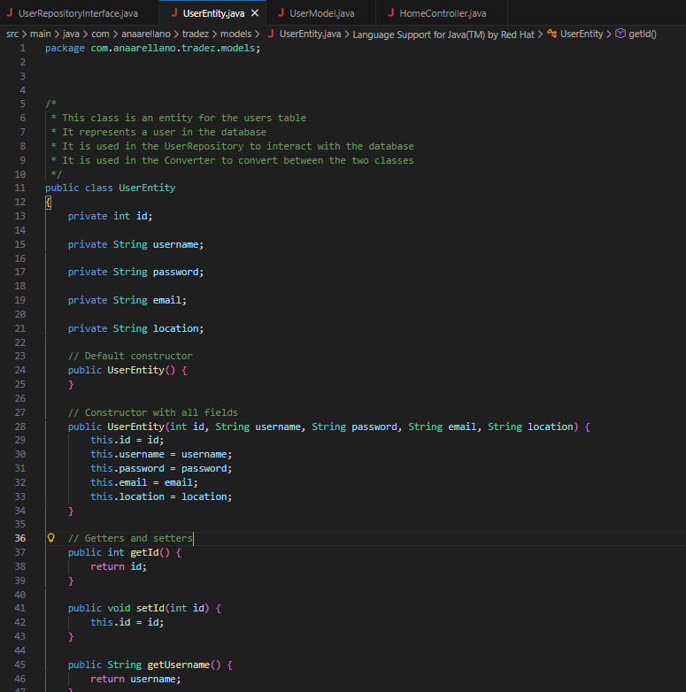
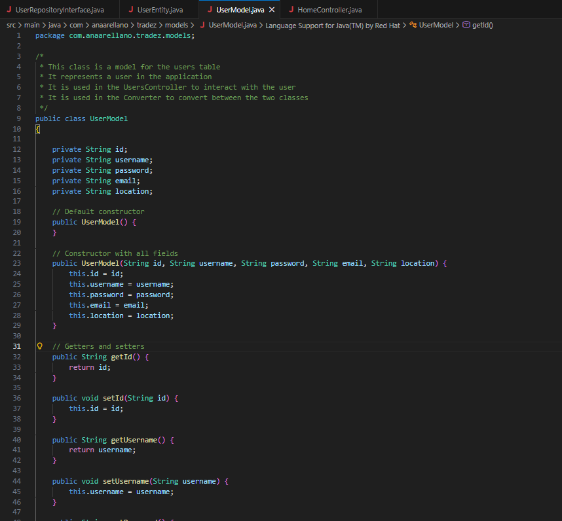
The models folder currently has the UserEntity, UserModel, and Converter. The UserEntity and UserModel both are modeled after the users table on the database and contain all the fields. The entity is used in the repository to interact with the database, and the model will be used in the controller to interact with the user. The converter class will convert the entity and the model to keep the data safe and will be used later on.

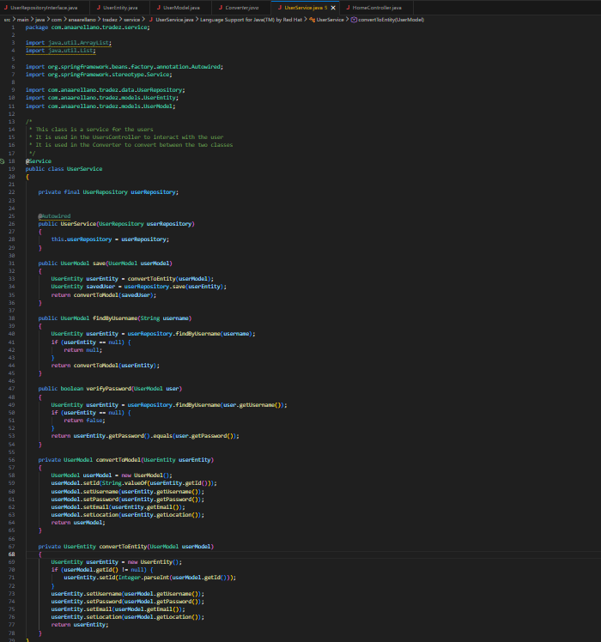
The service folder currently only contains the User Service. It keeps track of the data passed between the repository and controller. It converts between UserEntity and Usermodel and has the save and verifyPassword methods.

Test Plan and Test Cases
CST-451 Tradez Test Case.xlsx

Application Demonstration
https://www.loom.com/share/bc40d209ddb94145864b761f81dcc571

